**ANALYSIS OF FOOD BUSINESS OPPORTUNITY IN JAKARTA BASED ON DATA FROM FOURSQUARE PUBLIC API**

by Vicky Yuliandi

[vicky.yuliandi.s@gmail.com](mailto:vicky.yuliandi.s@gmail.com)

1. **Introduction**

Jakarta is Indonesia's massive capital. This city sits on the northwest coast of the island of Java. Indonesia is the largest economy of ASEAN, and Jakarta is the economic nerve center of the Indonesian archipelago. Hence, it is not surprising if this city attracts interest of people doing their business here.

Some people might be interested to start a food business in Jakarta. Some are experienced in this, some are new to this kind of business. Despite of how many experience they have, a good businessman should think of fundamental question about how to start their business. They may have at least two critical questions that we will discuss here. The first question is “what kind of food business that they should start with?”. With many kinds of food venue commonly found in the city, they should know which kind of food venue that they can make to compete with existing similar venues. The second question that they need to answer is “where in the city should they start this new food business?”. Obviously, Jakarta is a big city. Ones should be confused about deciding where to start its business in this city.

Data scientists should be challenged in answering this business problem. We can bring an analysis on the related market data to help answering these two questions. The analysis would be useful in guiding them to take right decisions. This report will focus on answering the business questions in the point of view of a data scientist.

1. **Data**

In order to answer those two critical questions, as a data scientist, we need to have data related to the food business market in Jakarta. One best thing that might come our mind now is to explore existing food market in all area in Jakarta. Therefore, firstly we need to have a list of area in Jakarta. Then, we will inspect the business market by finding data of existing foods venues in those areas.

In Indonesia, we have our own administrative division system [1].

**((Describe the division system))**

In this project we will only inspect the market up to the third level, that is *kecamatan* or sub-district in English. We will use list of sub-district in the city of Jakarta from wikipedia page [2]. The coordinate of the center of the sub-district will be used to find nearest food venues. Foursquare has public API that can provide us the data.

Foursquare has some account tiers for developers. Each tier has different set of available features [3]. In this project we are using personal tier. In this tier, we can get the data of venues near the specific location with specific category. We can use this feature to find existing food venues in Jakarta. The data should contain longitude, latitude, and the category of the venue. Processing and analysis will be done on this data to help us answer the business problem.

1. **Methodology**

There are steps that we need to do to answer the business problem. Here they are:

1. Web scrapping

Why? How?

1. Get longitude and latitude of each sub-district

Why? How?

1. Get list of food venues in each sub-district

Why? How?

1. Exploratory Data Analysis (EDA)

Why? How?

1. Cluster all sub-districts
   1. Data Preparation

Why? How?

* 1. Clustering

What kind of clustering algorithm that we would use? Why?

* 1. Cluster Visualization

How?

* 1. Cluster Analysis

How?

1. **Result and Discussion**

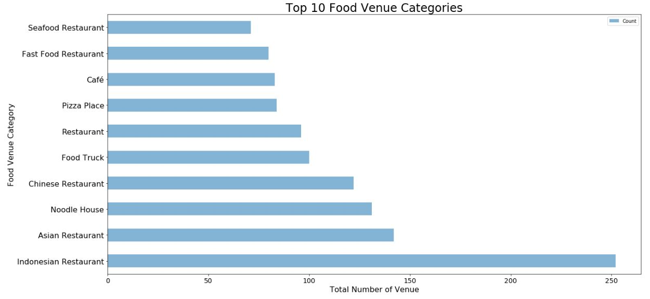

Figure 1: Top 10 food venue categories based on the total number of venue in each category

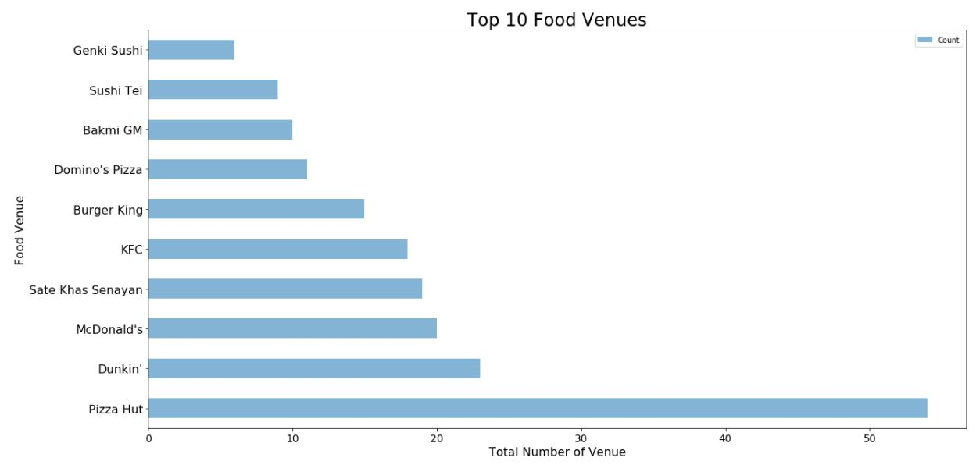

Figure 2: Top 10 food venues based on total number of same venue

Table 1: Cluster Analysis

|  |  |  |  |  |  |  |
| --- | --- | --- | --- | --- | --- | --- |
| Cluster | 0 | 1 | 2 | 3 | 4 | 5 |
| 1st Most Common Food Venue | Indonesian Restaurant | Indonesian Restaurant | Noodle House | Indonesian Restaurant | Asian Restaurant | Indonesian Restaurant |
| 2nd Most Common Food Venue | Asian Restaurant | Restaurant | Chinese Restaurant | Asian Restaurant | Diner | Pizza Place |
| 3rd Most Common Food Venue | Food Truck | Chinese Restaurant | Asian Restaurant | Japanese Restaurant | Indonesian Restaurant | Restaurant |
| 4th Most Common Food Venue | Fast Food Restaurant | Japanese Restaurant | Indonesian Restaurant | Caffé | Seafood Restaurant | Food Truck |
| 5th Most Common Food Venue | Noodle House | Caffé | Seafood Restaurant | Chinese Restaurant | Wings Joint | Asian Restaurant |
| 6th Most Common Food Venue | Restaurant | Fast Food Restaurant | Food Truck | Food Truck | Food | Seafood Restaurant |
| 7th Most Common Food Venue | Caffé | Asian Restaurant | Caffé | Noodle House | Donut Shop | Noodle House |
| 8th Most Common Food Venue | Food Court | Steakhouse | Pizza Place | Restaurant | Dumpling Restaurant | Fast Food Restaurant |
| 9th Most Common Food Venue | Pizza Place | Bakery | Restaurant | Sushi Restaurant | Eastern European Restaurant | Caffé |
| 10th Most Common Food Venue | Donut Shop | Noodle House | Japanese Restaurant | Korean Restaurant | Fast Food Restaurant | Indonesian Meatball Place |

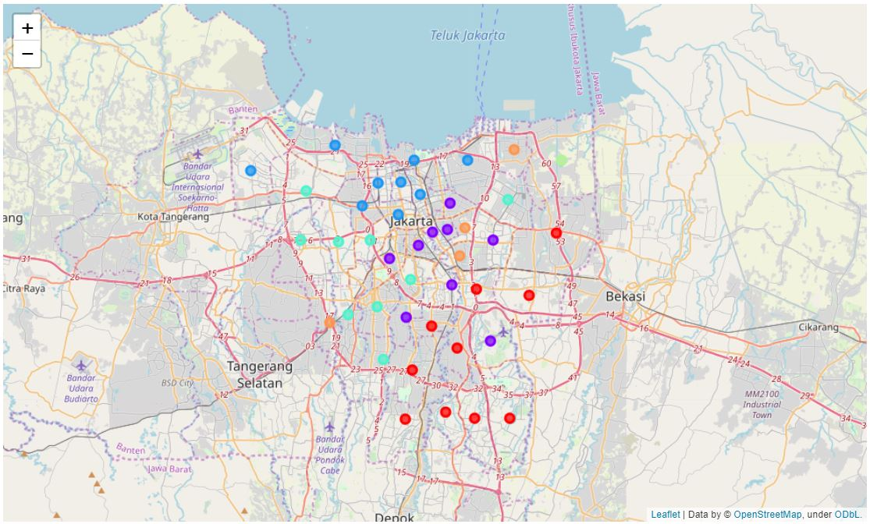

Figure 3: Map of sub-district cluster

1. **Conclusion**

Lorem ipsum dolor sit …

1. **Further Direction**

Use premium developer account to get more detailed data of the venue, such as menu, rating, likes, visits count, etc. This will improve the analysis and help us more in answering what kind of food potentially likeable menu that we can offer in our food venue.

1. **Reference**
2. <https://en.wikipedia.org/wiki/Subdivisions_of_Indonesia>
3. <https://id.wikipedia.org/wiki/Daftar_kecamatan_dan_kelurahan_di_Daerah_Khusus_Ibukota_Jakarta>
4. <https://developer.foursquare.com/docs>